RLS Demo

There are 2 users:

1. Mandar with email id as [bi_reporting@mandarpowerbi.onmicrosoft.com](mailto:bi_reporting@mandarpowerbi.onmicrosoft.com)

Mandar is admin user as well.

1. Martin with email id as [bi_reporting2@mandarpowerbi.onmicrosoft.com](mailto:bi_reporting2@mandarpowerbi.onmicrosoft.com)

Mandar user has created one report based on T-shirts Data. He wants to share his report with Martin. **But** Mandar wants to make such an arrangement that Martin should be able to get the **data of Order date after 31-Dec-2013 and that too of colors red, blue and black only.**

Steps:

1. Mandar creates a PBI Desktop report by importing data.
2. A slicer is placed which has Year from Order Date, and simple bar chart is created which has color and qty as shown next 🡪

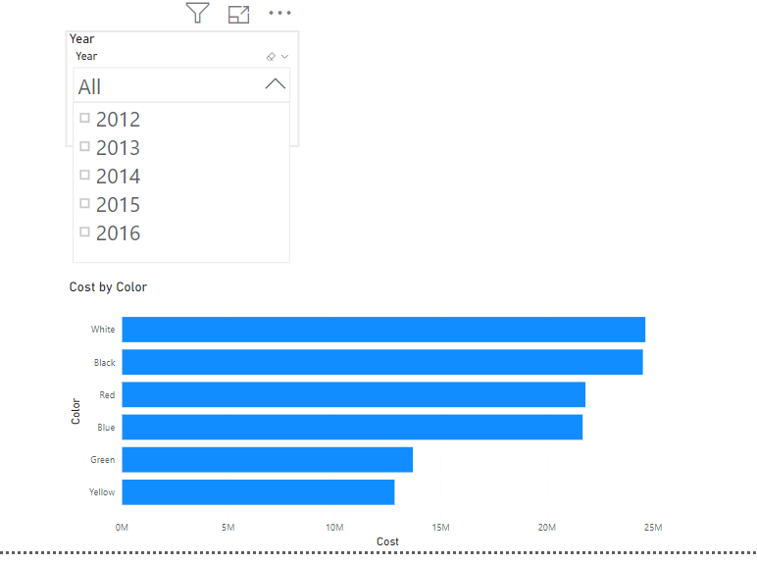

1. *** Through Modeling tab click on Manage Roles, and then click on Create button.
2. Provide name as User_data
3. The Filter Expression will be as follows:

**([Color] = "Red" || [Color] = "Black" || [Color] = "Blue") && [Order Date] >= DATE(2014,01,01)**

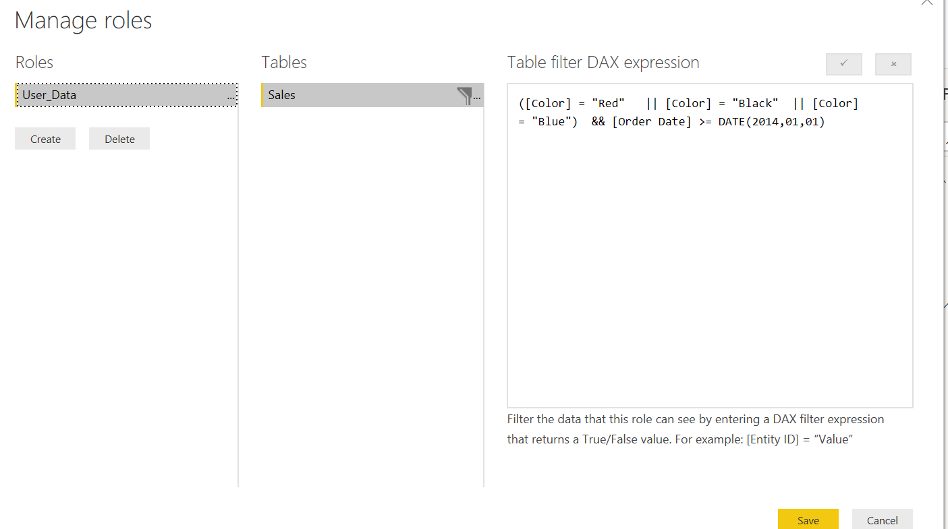

1. We can **test** the role in PBI Desktop itself!! For that click on **View as roles** icon and select User_Data

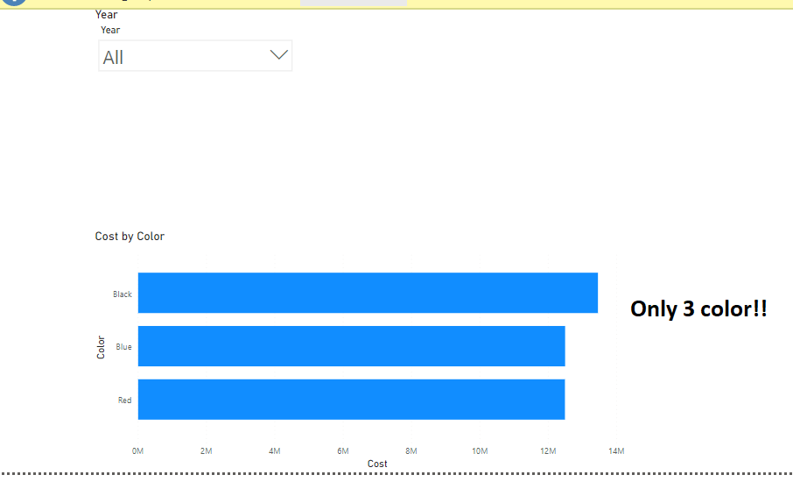

Also, if 2012 year is selected then nothing will be shown in bar chart!!!

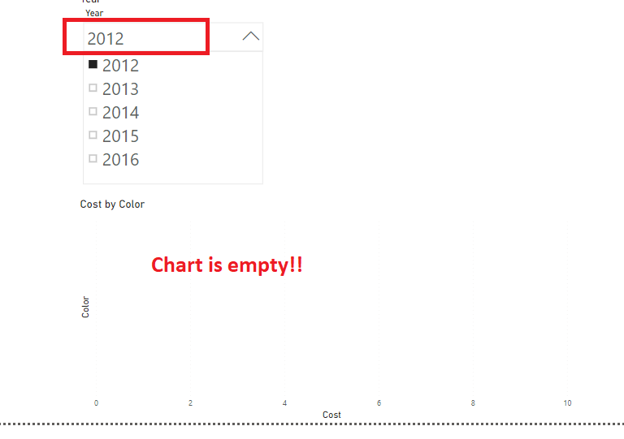

Save the file as **Sales Report 1** and **Publish** it.

**** RLS is to be created in PBI Desktop. But needs to be assigned to user (s) in PBI Service.

1. Login to PBI Services as Mandar user (i.e. Admin User).
2. **\*\*\*\*\*\*\*\*\***From DATASETS select the … of Sales Report 1. And then select Security as shown next.

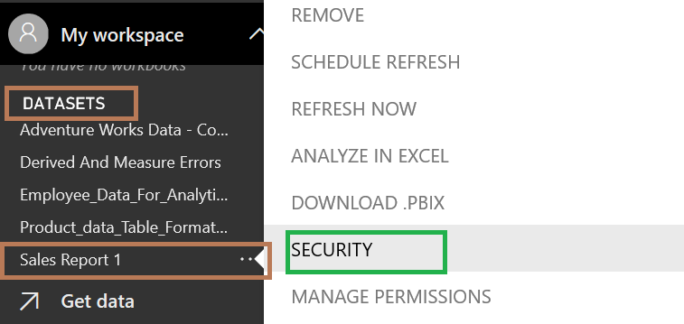

1. Mention Martin’s email address and click on Add button as shown next.

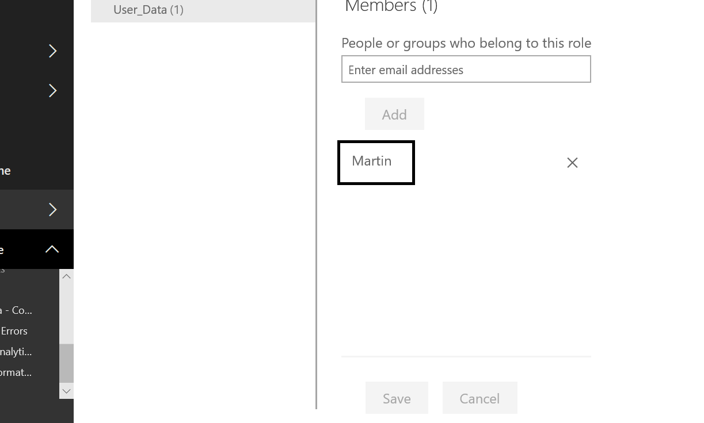

1. **** Now the report also needs to be shared with Martin.
   1. Click on My Workspace
   2. Select Reports tab. And click on the Share icon of Sales Report 1 as shown next 🡪

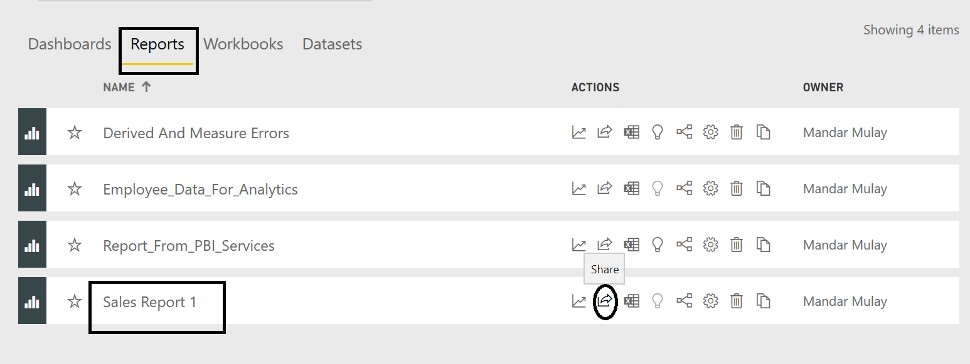

**\*\*\*\*\*\*\*\*\*\*\*Sharing Reports and Dashboard is only available for Power BI Pro Users. So, if at this point of time if the current user is not a Power BI Pro user then it will give the following message:\*\*\*\*\*\*\*\*\*\*\*\*\*\*\***

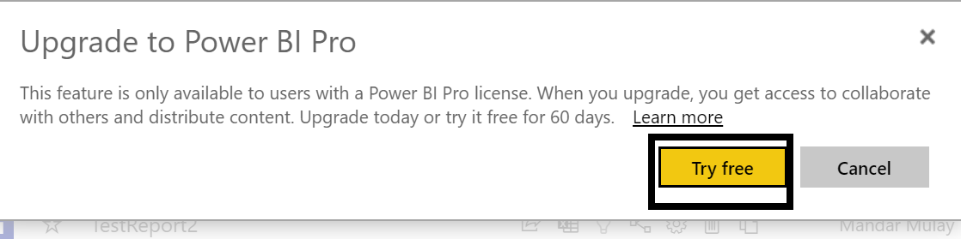

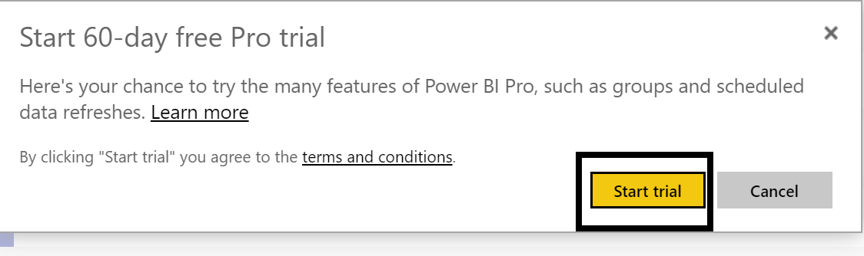

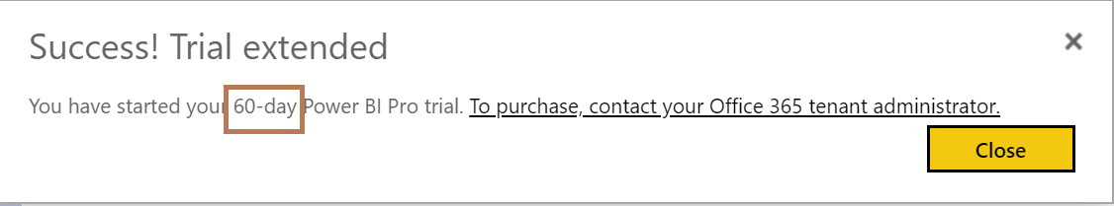

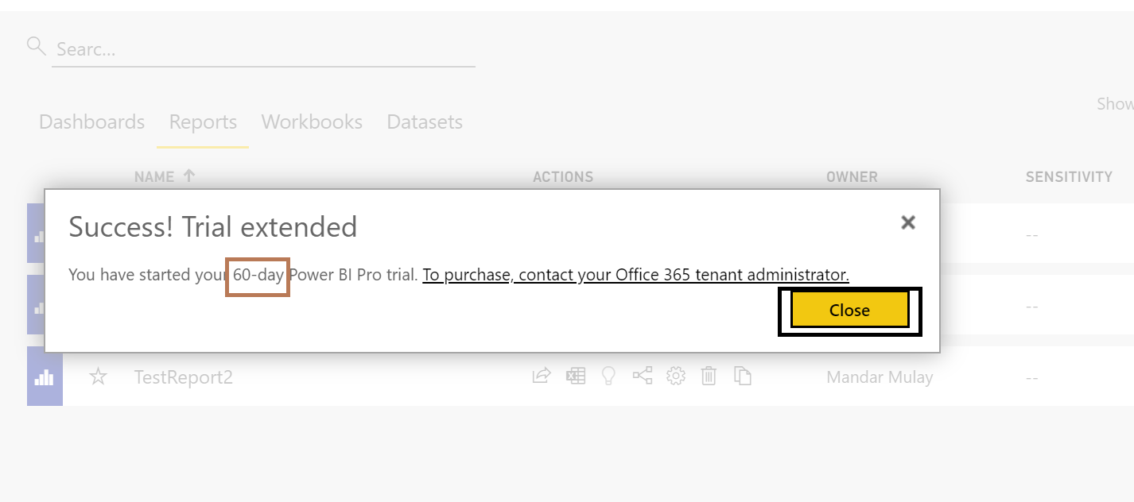

Immediately on the title bar 59 days left notification gets reflected as shown next 🡪

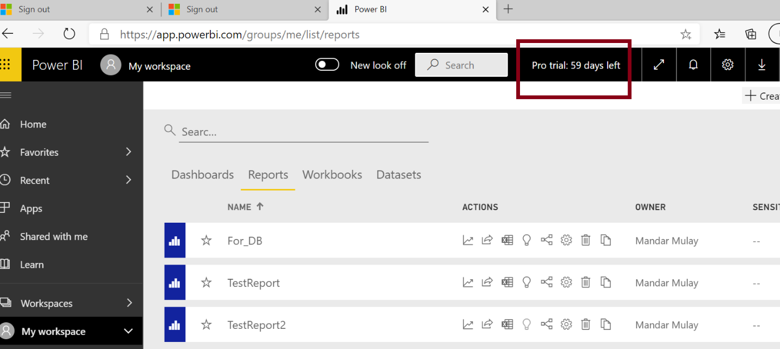

1. Now **again** the report also needs to be shared with Martin.
   1. Click on My Workspace
   2. Select Reports tab. And click on the Share icon of Sales Report 1 as shown next 🡪



* 1. Type Martin’s email address and click on Share as shown next 🡪

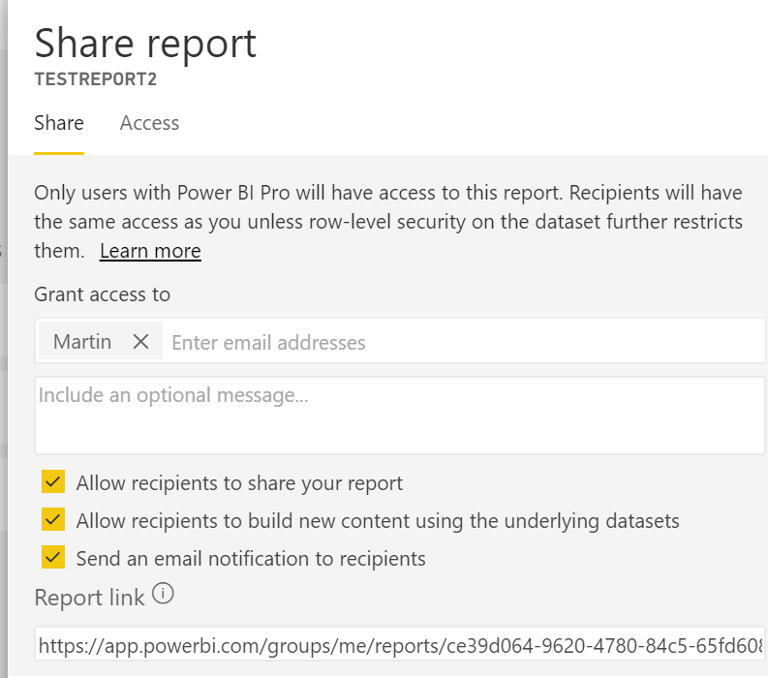

1. Remove selection of all 3 check boxes and click on the Share button as shown next 🡪

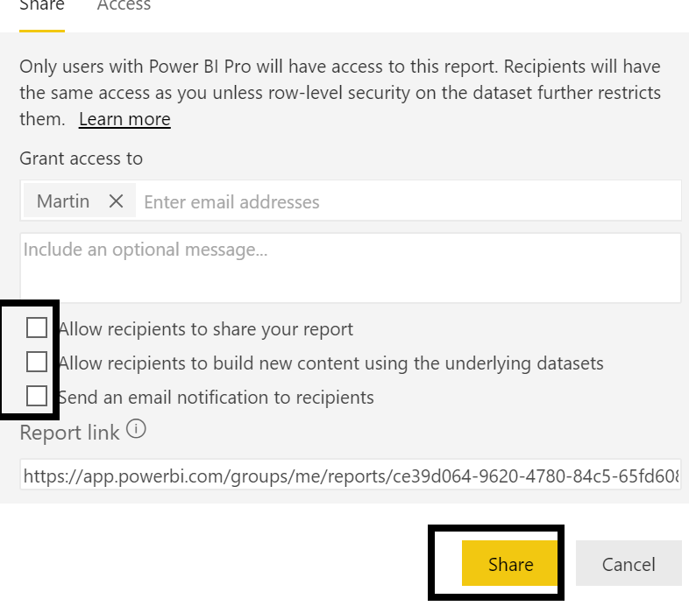

1. It gives us the positive feedback on the title bar as shown next 🡪

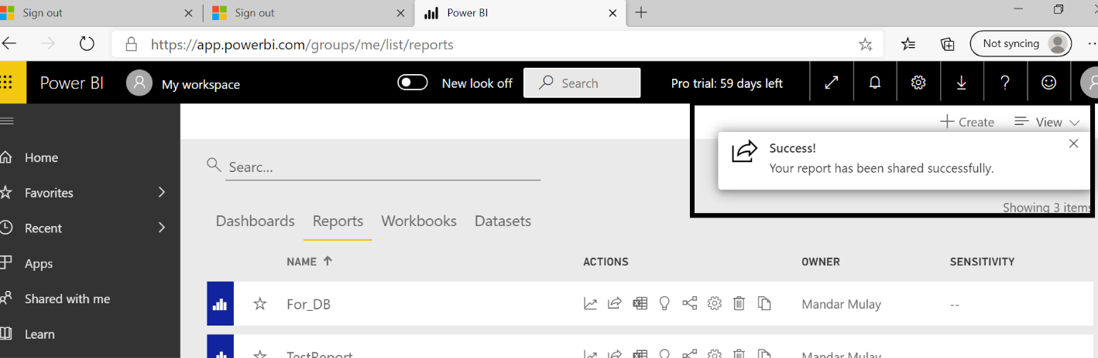

1. **Cross check**
   1. Logout from Mandar account
   2. Login by Martin’s account
   3. Click on **Shared with me** as shown next 🡪

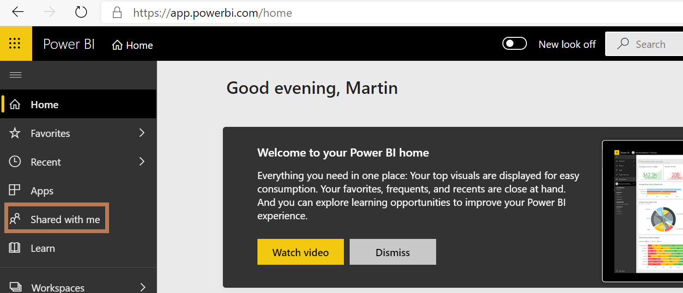

* 1. Click on the Sales Report 1 as shown next.

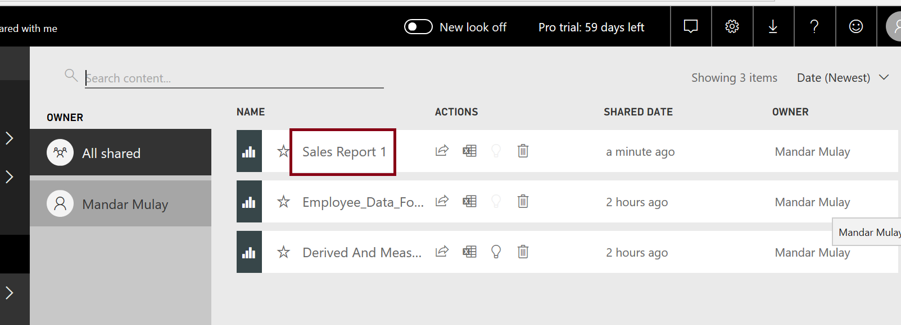

Now, Marin also should be a Power BI Pro user. So complete the same steps like what we did for the owner Mandar user.

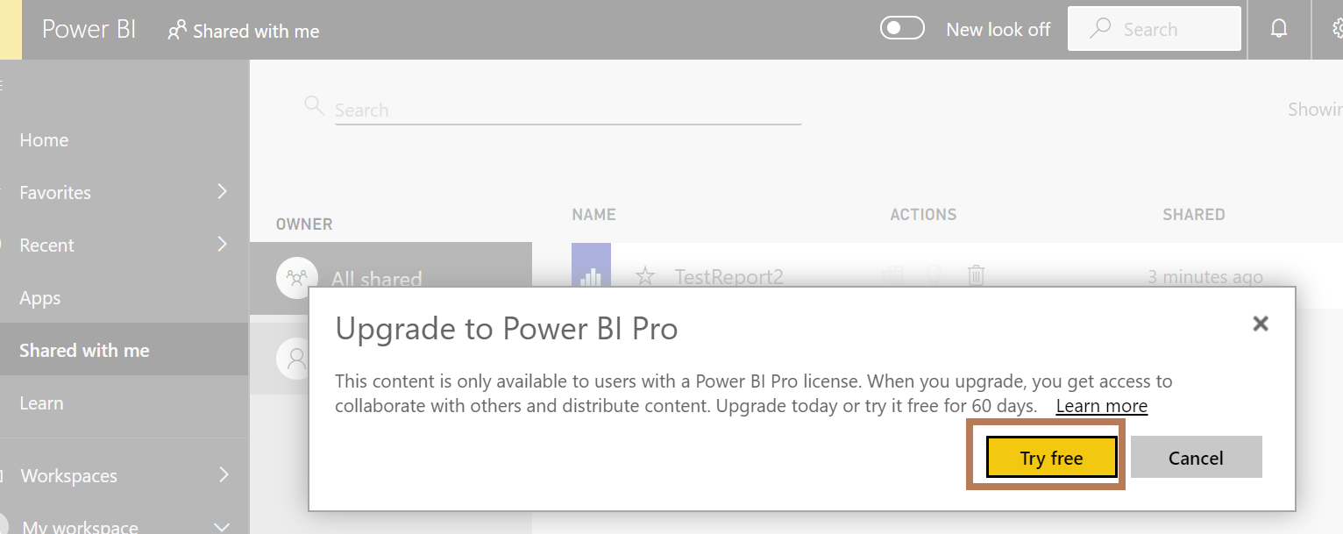

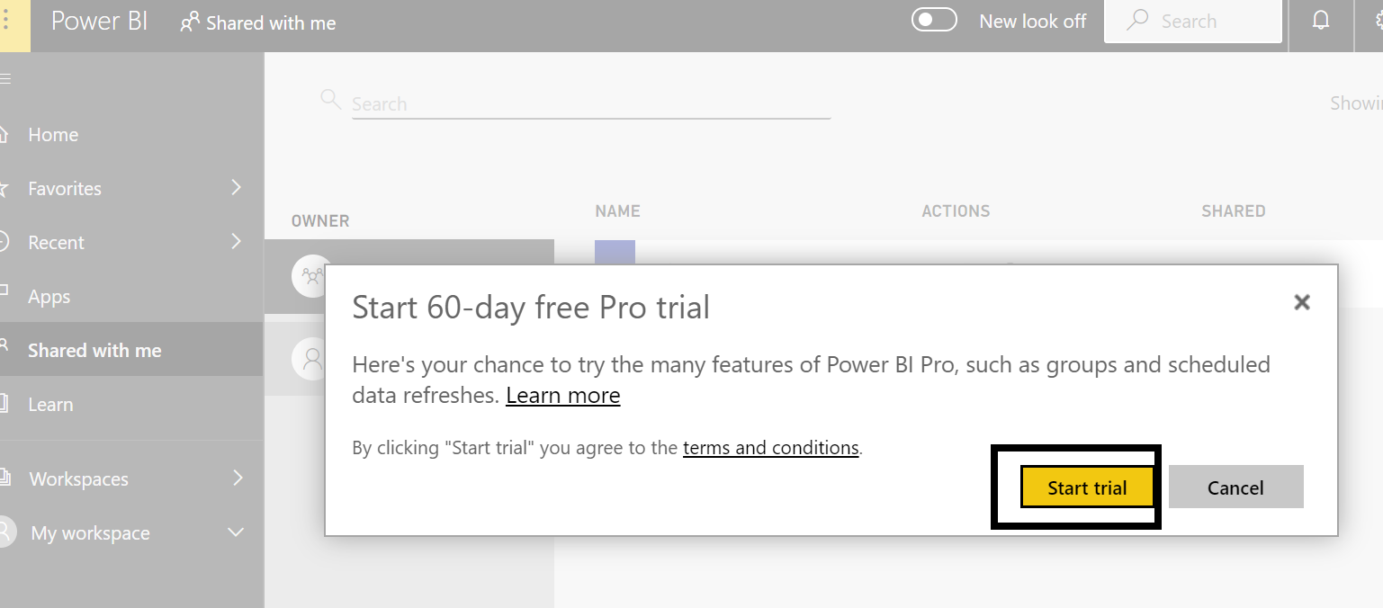

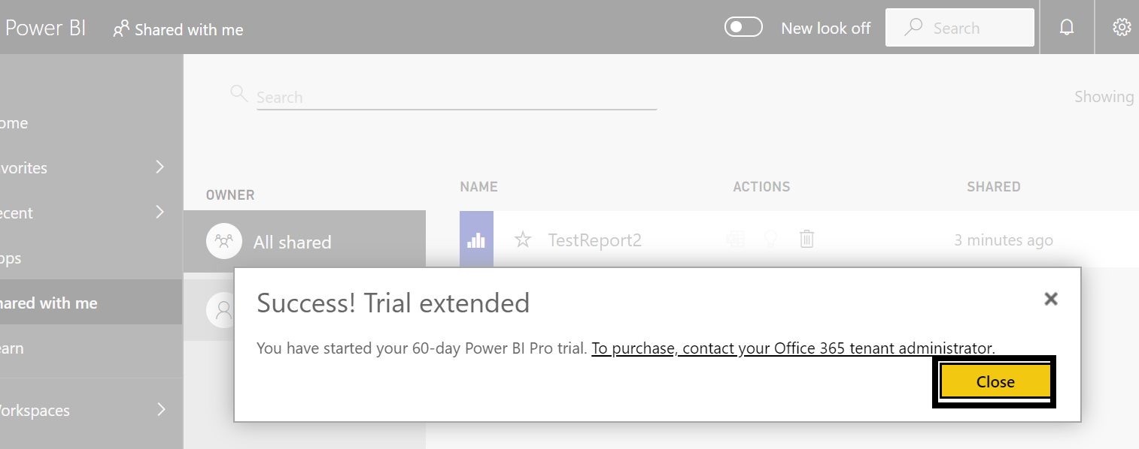

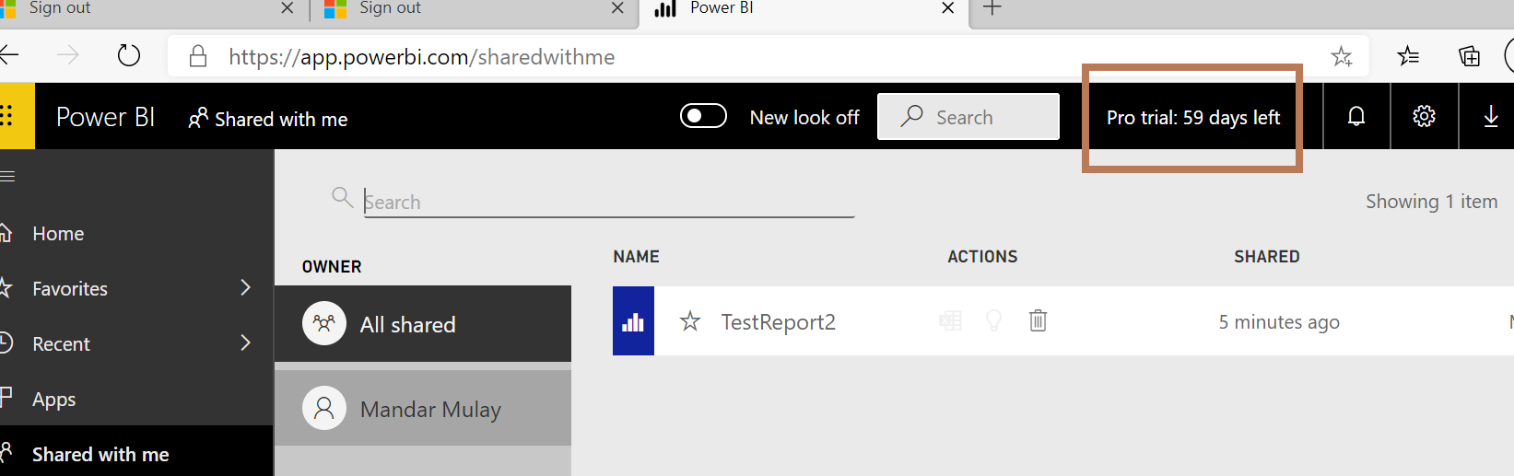

Finally, click on the **Sales Report 1** within the **Shared with Me** section

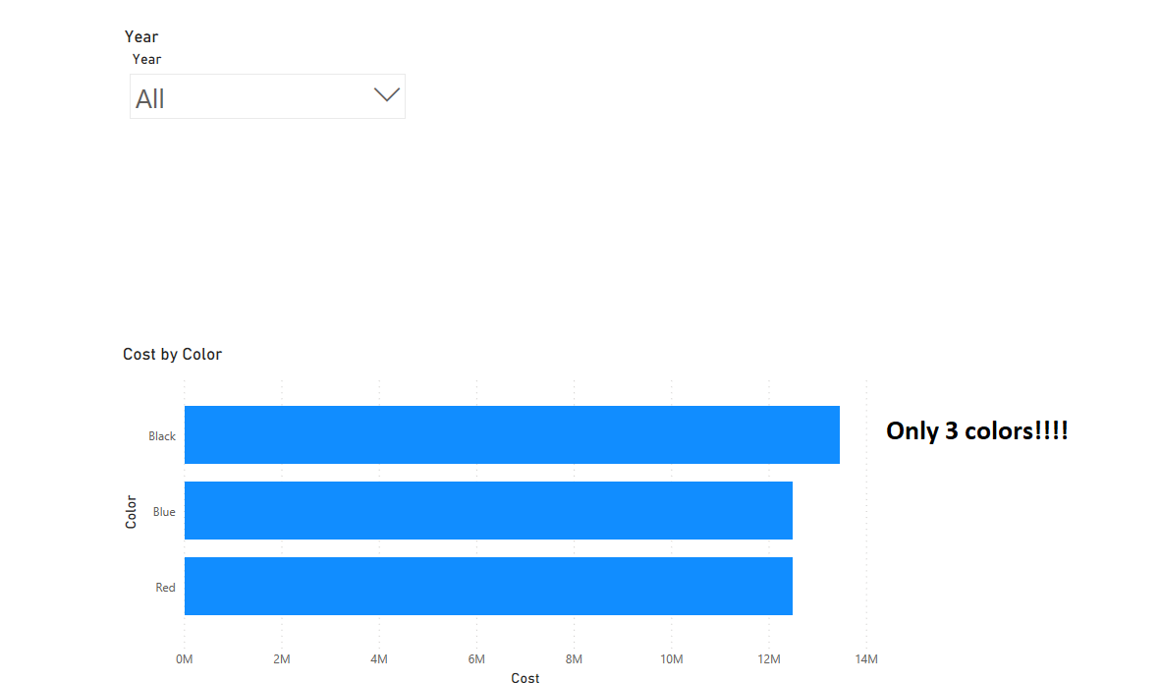

**RLS has to be created in PBI Desktop. (Only Developer)**

**But RLS has to be implemented in PBI Service. (Generally, by Administrator, sometimes by Developer)**